1. What effect does folding the foil in half have on capacitance? Explain this both in terms of your observation and in terms of the physics of the capacitor.
   1. Folding the foil in half would theoretically reduce the capacitance of the foil capacitor because folding each side of the capacitor in half would reduce the capacitance. Capacitance is calculated based on area of the sides of the capacitor and the distance between the sides. Folding the capacitor sides would reduce the capacitance by reducing the area of the sides. The TA did not demonstrate the effects of folding on the capacitance in class, but the effects mentioned above would ensue.
2. Calculate the energy stored in the fully charged capacitor (with un-certainty for this question). You may assume the voltage of the power supply had no uncertainty.
   1. $$E_{stored}= \frac{1}{2}CV^{2}$$ C = 178 pF – 20.5 pF = 158 pF V = 6000 V
 $$E_{stored}= \frac{1}{2}(158 x {10}^{-12} pF)({6000 v)}^{2}$$

 $$E_{stored}=$$ 2. 5.69 x 10-3 J
      1. *uncertainty for any values of capacitance were not provided at the time of the demonstration, no error or error propagation calculations could be done.
3. Using only the measurements of capacitance with and without the rubber sheet show how you can calculate the relative permittivity, r of the rubber. Assume r = 1 for air.
   1. The area of the plates did not change between measurements
   2. The distance did not change, the rubber was squeezed between the plates, and then the rubber was carefully removed from between the plates to preserve the distance between the plates.
   3. The formula for capacitance is $$C= ϵ_{R}ϵ_{0}\frac{A}{d}$$, the $$ϵ_{0}\frac{A}{d}$$ portion does not change and only the relative permittivity of the materials changes.
   4. Since $$ϵ_{R}$$ in the one with air is 1, it will be plugged in.
   5. Crubber = (180.1 ± 0.1 pF) - (20.75 ± 0.45 pF) = 159.4 ± 0.6 pF
   6. Cair = (45.75 ± 0.15 pF) - (21.35 ± 0.05 pF) = 24.4 ±0.2 pF
   7. $$ϵ_{R}$$ (24.4 pF) = (159.4 pF)
   8. (159.4 pF)/(24.4 pF) = 6.53 = $$ϵ_{R}$$ is the relative permittivity of the rubber
4. Does the light bulb stay lit for the same amount of time when charging and discharging the capacitor? Why should it be the same or not? Hint: The bulb’s brightness corresponds to current but requires a minimum amount of current to stay lit, so a dim bulb doesn’t immediately mean I = 0.
   1. The light bulb does not have the same time spent lit while charging and discharging, it generally spends more time lit in the charging phase than in the discharging phase. the light bulb stay lit longer during charging becasue the capacitor charges, the resistance begins to increase, reducing the volage change, the loss of voltage change means less and less power for the light bulb, beyond a minimum voltage, the lightbulb shuts. During the charging, the capacitor acts like a wire, but gains resistance as time goes by, during discharge, the opposite happens, but the capacitor doing this in reverse loses voltage faster the longer the circuit is closed, meaning that the light bulb will go out faster in the discharge phase.

Measured Values

* Diameter of plates: 19.70 cm ± 0.02 cm
* 500 sheet thickness = 3.23 cm ± 0.01 cm
* Individual sheet thickness = (500 sheet thickness/500) = 0.00646 ± 0.00002 cm

Calculation of A

* d = 19.70 $±$ 0.01 cm, r = d/2 = 8.85 cm $±$ 0.01 cm
* A = πr2 A = π(8.85 cm)2 = 246 cm2
* 𝛅A = = = 0.556
* A = 246 ± 1 cm2

Table of Capacitances of Parallel Plates with Sheets of Paper in Between

|  |  |  |  |  |  |
| --- | --- | --- | --- | --- | --- |
| Number of Sheets | Plate separation (d) (cm) | 1/d  (cm-1) | Capacitance of Leads (Cleads) | Capacitance total  (Ctotal) | Corrected Capacitance ( C ) |
| 25 | 0.162 | 6.19 | 20.95 ± 0.05 pF | 0.57 ± 0.01 nF | 0.549 ± 0.01 nF |
| 50 | 0.323 | 3.10 | 21.85 ± 0.25 pF | 196.9 ± 0.1 pF | 176.45 ± 0.25 pF |
| 75 | 0.485 | 2.06 | 20.45 ± 0.05 pF | 162.3 ± 0.2 pF | 141.9 ± 0.3 pF |
| 100 | 0.646 | 1.55 | 20.35 ± 0.05 pF | 135.55 ± 0.15 pF | 115.2 ± 0.2 pF |
| 125 | 0.808 | 1.24 | 21.6 ± 0.6 pF | 120.85 ± 0.75 pF | 99 ± 1 pF |
| 150 | 0.969 | 1.03 | 21.1 ± 0.2 pF | 118.35 ± 0.25 pF | 97.3 ± 0.5 pF |
| 175 | 1.13 | 0.885 | 22.55 ± 0.05 pF | 107.65 ± 0.35 pF | 85.1 ± 0.4 pF |
| 200 | 1.29 | 0.774 | 22.5 ± 0.2 pF | 96.75 ± 0.45 pF | 74.3 ± 0.7 pF |
| 250 | 1.62 | 0.619 | 22.45 ± 0.15 pF | 95.4 ± 0.2 pF | 72.9 ± 0.4 pF |
| 300 | 1.94 | 0.516 | 21.9 ± 0.1 pF | 85.55 ± 0.35 pF | 63.7 ± 0.5 pF |
| 350 | 2.26 | 0.442 | 22.1 ± 0.2 pF | 73.1 ± 0.2 pF | 51.0 ± 0.4 pF |
| 400 | 2.58 | 0.387 | 22.35 ± 0.05 pF | 72.45 ± 0.15 pF | 50.1 ± 0.2 pF |

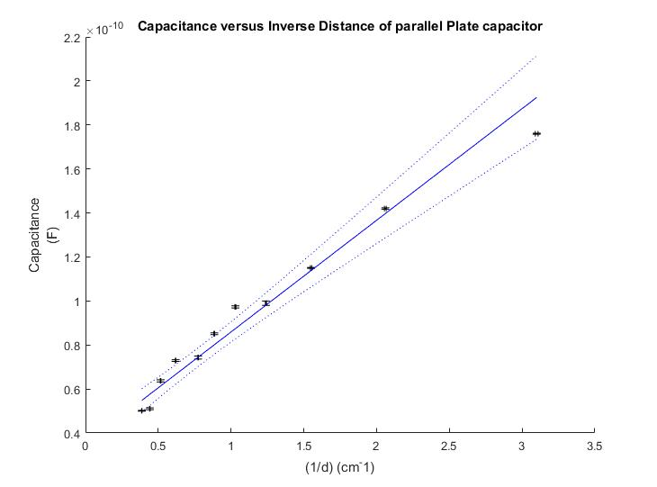Chose linear function because most obvious fit (logarithmic function to be employed later)

Linear model I(V;m,b)=m*V+b

---------------------------

Enter estimate for parameter m: 0.05

Enter estimate for parameter b: 0.04

Parameter 1: p(1) = 5.074323e-11 +/- 3.524068e-12

Parameter 2: p(2) = 3.518053e-11 +/- 3.336914e-12

Parameter m = 5.074323e-11 +/- 3.524068e-12

Parameter b = 3.518053e-11 +/- 3.336914e-12

Relative permittivity of Paper: 𝜖r = m/A

m = 5.1 x 10-11 ± 0.4 x 10-11 A = 246 ± 1 cm2

𝜖r = m/A = 5.1 x 10-11/ 246 cm2 = 2.1 x 10-9

𝛿d =

𝛿d = = 8.4 x 10-10

𝜖r = 2.1 x 10-9 ± 0.84 x 10-10 / 𝜖0 (8.85x10-12) = 235 ± 95 relative permittivity

Section 7

|  |  |
| --- | --- |
| Resistance (ohms) | Tau |
| 99.4 ± 0.1 | 3.632236e-02 +/- 3.632883e-04 |
| 148.55 ± 0.05 | 4.751269e-02 +/- 2.848536e-05 |
| 322.2 ± 0.1 | 1.031847e-01 +/- 5.699946e-05 |
| 555.9 ± 0.3 | 1.781427e-01 +/- 5.611229e-05 |
| 997 ± 1 | 3.211907e-01 +/- 7.603611e-05 |
| 9990 ± 100 | 3.215192e+00 +/- 9.940576e-04 |

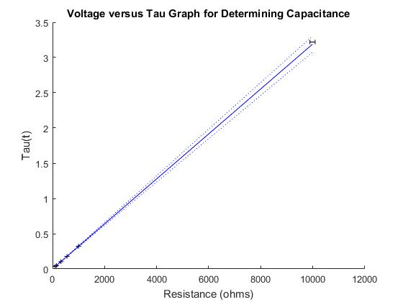

Linear model I(V;m,b)=m*V+b

---------------------------

Enter estimate for parameter m: 0.000330

Enter estimate for parameter b: 0

Parameter 1: p(1) = 3.191457e-04 +/- 4.216521e-06

Parameter 2: p(2) = 1.226457e-03 +/- 1.358115e-03

Parameter m = 3.191457e-04 +/- 4.216521e-06

Parameter b = 1.226457e-03 +/- 1.358115e-03

Capacitance from the graph: 319 ± 6 μF Capacitance expected: 307 ± 1 μF

t = $\frac{\left|x_{th}-x_{meas}\right|}{\sqrt{σ_{th}^{2}+σ_{meas}^{2}}}$ t = $\frac{\left|307-319\right|}{\sqrt{1_{}^{2}+6_{}^{2}}}$ = 1.97 → 95.12

Discussion

3. 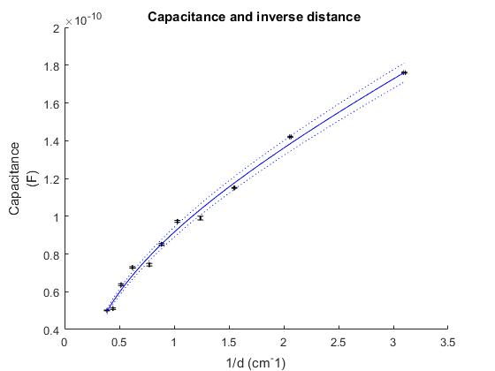

* Parameter 1: p(1) = 9.548257e-11 +/- 1.225139e-12
* Parameter 2: p(2) = 2.906218e-01 +/- 1.750019e-22
* Parameter 3: p(3) = 1.052199e+00 +/- 1.314938e-22
* Parameter epsilon = 9.548257e-11 +/- 1.225139e-12
* Parameter radius = 2.906218e-01 +/- 1.750019e-22
  + relative permittivity = 9.548257e-11 +/- 1.225139e-12 / 𝜖0 
    - 11 relative permeability
      * this value is much lower than the calculated value from the linear fitted graph and is probably much more accurate too
* The y-intercept should not belong on either model, but it’s existance points towards the precision of the measurement, the closer it is to zero, the more precise the measurement.